Step 2: Go to ‘Virtual machines’
‘Virtual machines’ may appear on your Azure Portal home page. In this case, just click on the button.
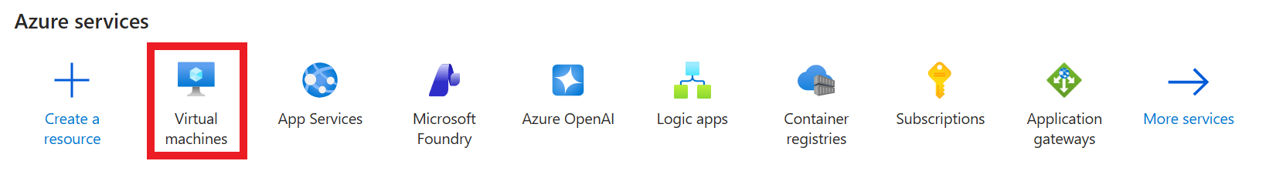

Otherwise, look up Virtual machines in the search bar.
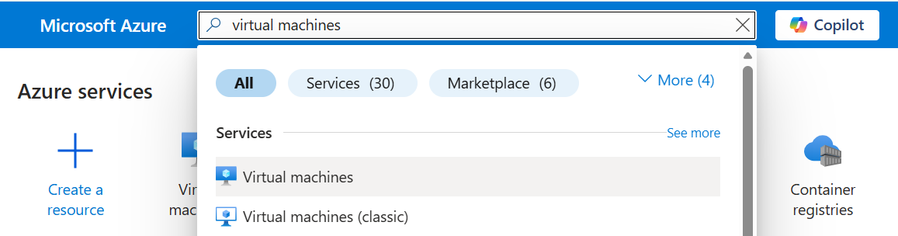

Step 3: Click on the jumphost VM that your team has been assigned to (Appendix A)
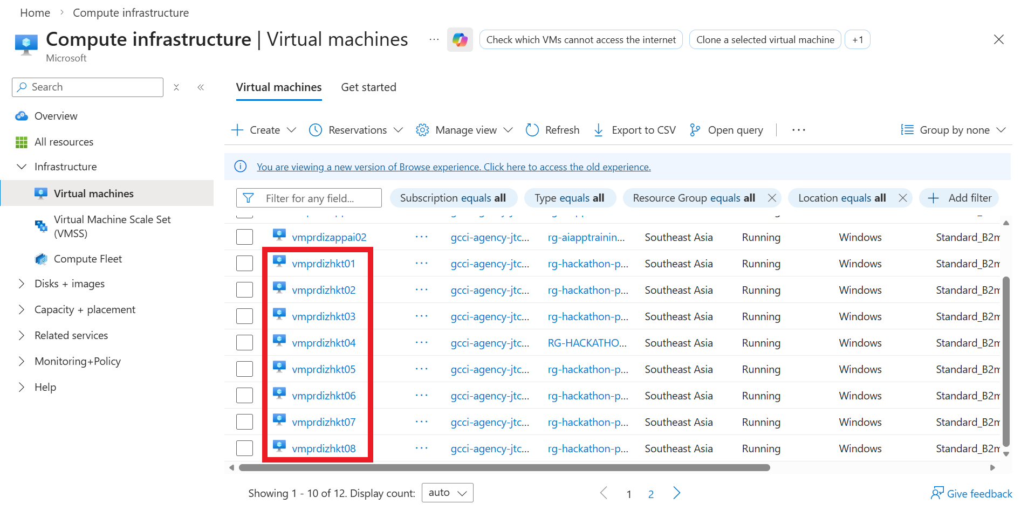

Step 4: Click on ‘Connect via Bastion’
On the landing page for your team’s VM (not necessarily vmprdizhkt01), hover over ‘Connect’ and click ‘Connect via Bastion’.
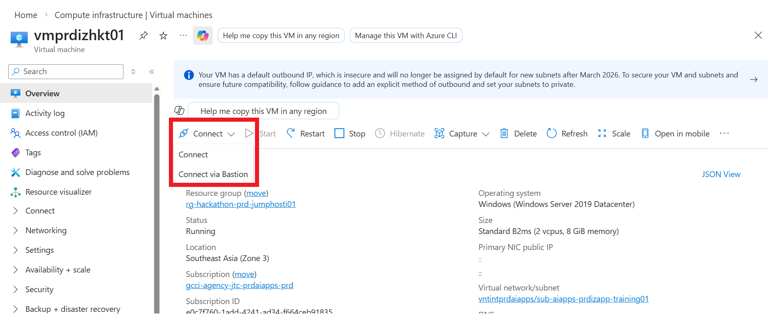

Step 5: Connect via Bastion
Protocol should be set to RDP. Port should be set to 3389. Authentication Type should be set to VM Password. Here, log in with your GCC AD credentials (not your usual windows AD log in).
You might be prompted to change password on first log in.
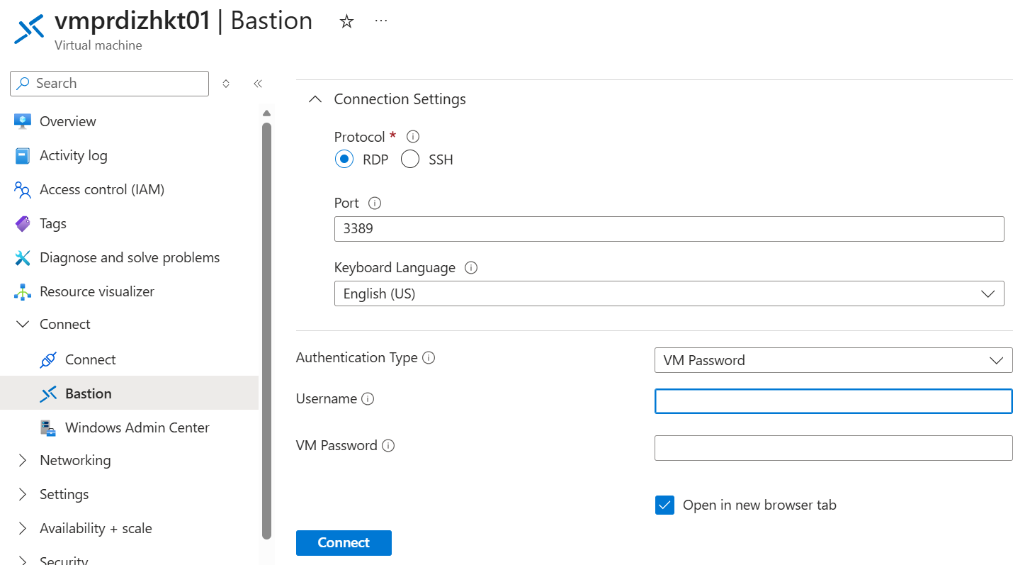
Note that each VM can only support two concurrent users. If more than two users try to access the VM, you will be prompted to boot one user out.
Your VM should appear in a new window.

Step 6 (only for first time log in for each user): Change GCC AD password
Press Ctrl+Alt+End on your keyboard. On the HP Dragonfly, this would be Ctrl+Alt+Function+Right button.

Change your password to your own password. This will be your new GCC AD password, which you will use to access the jumphost VM. Make sure to remember this password!

Step 7: Launch Microsoft Edge on your VM desktop
